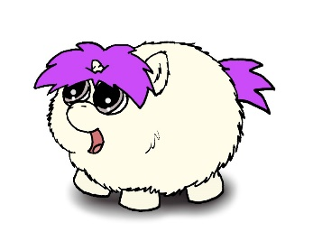
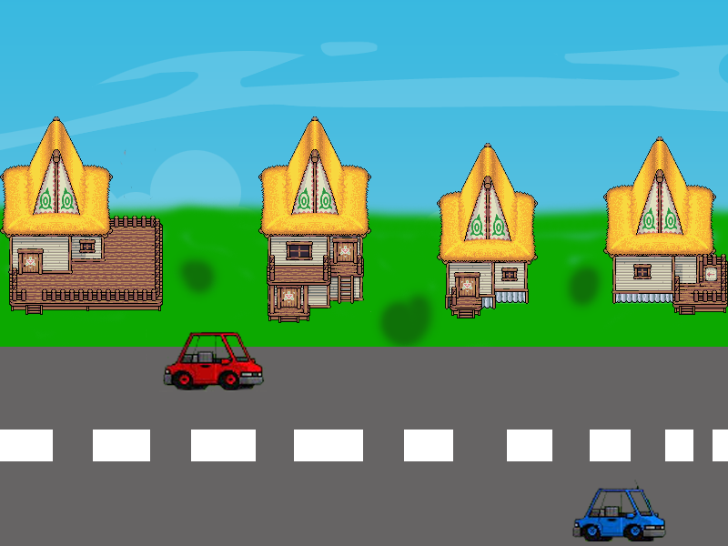
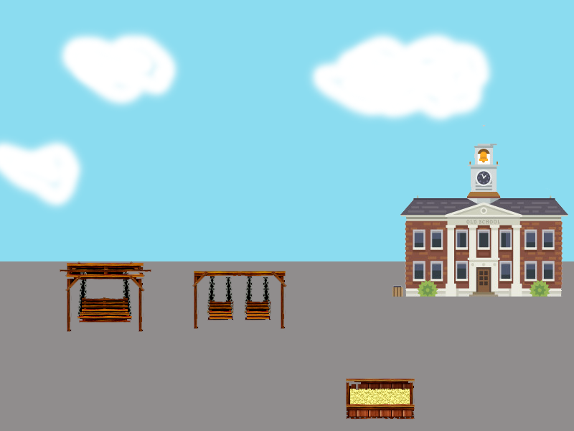
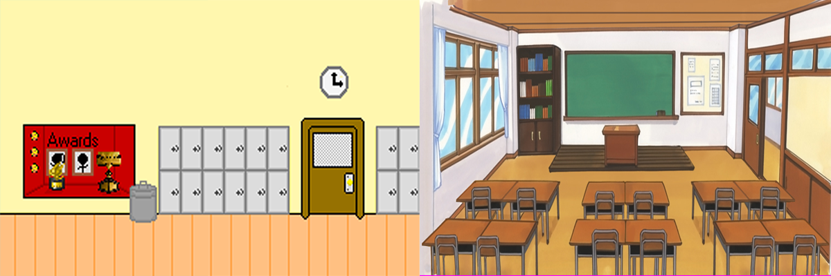
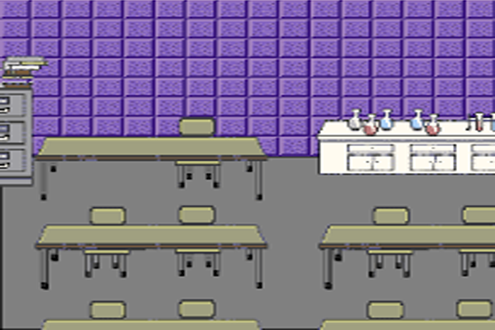
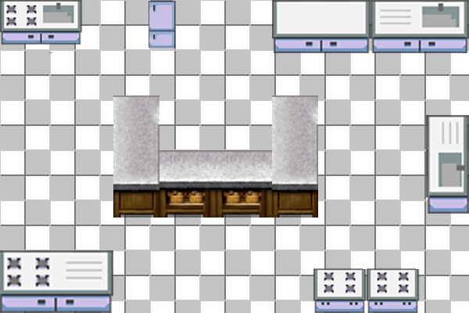
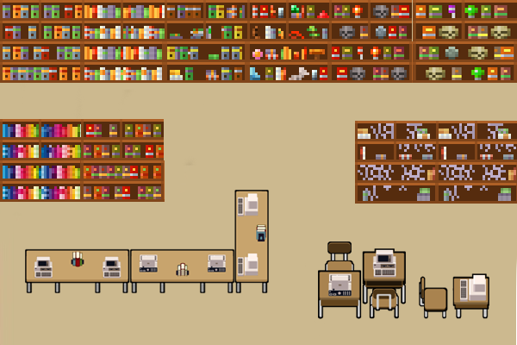
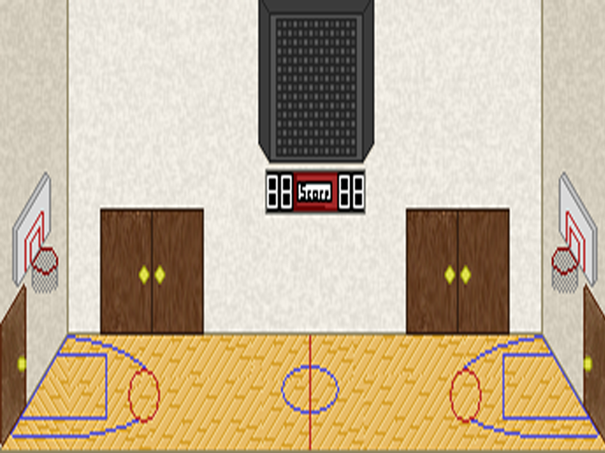
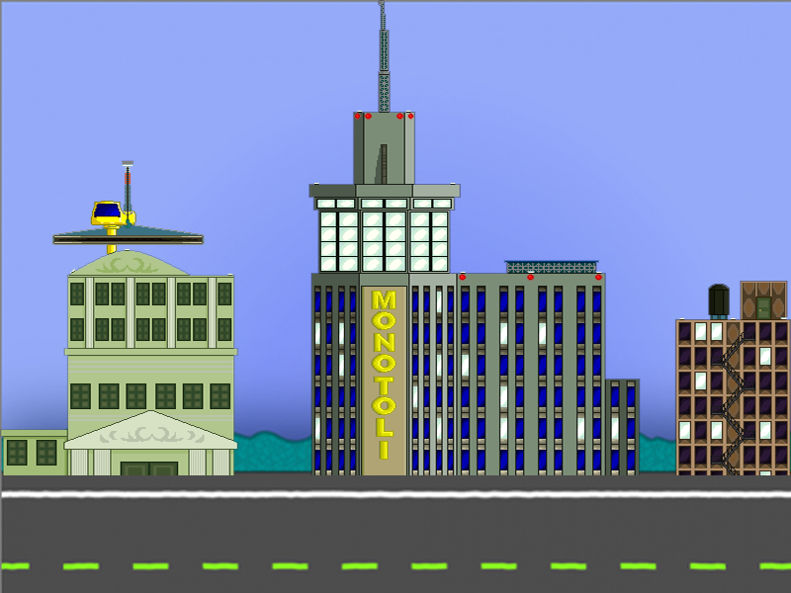
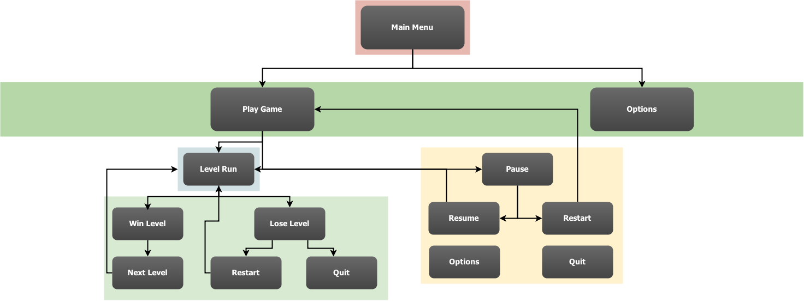

Contents
1Team Personnel 3
2Game Overview 3
2.1Game Description 3
2.2Genre 3
2.3Audience 3
2.4Platform/Hardware 3
2.5Requirements 3
3Plot and Setting Information 3
3.1Story 3
3.2Characters 3
3.3Enemies 4
3.3.1Basic Enemies 4
3.3.2Bosses 4
3.4Levels 4
4Core Gameplay 8
4.1Levels 8
4.2Movement 8
4.3Upgrades 8
4.4Beans 8
4.5Controls 8
4.6Artificial Intelligence 8
4.7Power-Ups 9
4.8Destructible Objects 9
4.9Secret Areas/Events 9
4.10Stats Explanation 9
5Player and Enemy Stats 10
5.1Player Stats 10
5.2Enemy Stats 10
5.3Life Bars (HUD) 12
6Interface and Interface Usage 12
6.1Main Menu Interface 12
6.2Game Menu Interface 12
7Menu and General Game Usage 12
7.1Game Flow Diagram 12
8Audio 12
9Notes 13
10Wish list 13
11Development Technical Milestones 13
11.1Alpha Version 13
11.2Beta Version 13
11.3Silver Version 14
11.4Gold Version 14

Team Personnel
Director and Programming Lead: Alexander Sanchez
Visual Artist: Alexander Sanchez
Programming Team Lead: Andrew Best
Programming Interns: Brandon Coulthard and Jon MacLachlan

Game Overview

Game Description
Fluffy Unicorn is a single player experience, following Fluffy the Unicorn through his adventures in converting what were once bullies into his new found friends.
Fluffy wants nothing more than for the world to be rid of bullies. Everyone should be friends! One night he wishes upon a shooting star for everyone to be friends and the next day he wakes up as a Unicorn. Fluffy makes it his mission to rid the town of all bullies by using his new power of farting rainbows to turn them into his friends.

Genre
Side-scrolling shooter

Audience
- General Audience
- Video Game Fanatics
- Ages 5 and up

Platform/Hardware
The game will be developed using Unity’s free license. This means that there will be no costs for software used in developing the game. Since we are using Unity, we can target many platforms. However, to begin with, we will be submitting the game to the Android Play Store and the Apple App Store.

Requirements

Plot and Setting Information

Story
The game starts off with a cut-scene showing Fluffy being bullied by a group of kids at school. It shows Fluffy being beat up and left on the ground with the bullies laughing at him. The scene fades out and shows Fluffy walking home slowly while limping.

The next scene is Fluffy dreaming about his next day at school, and shows Fluffy being friends with all the kids at school , and he is happy.

The next scene is when the game starts. You start to control Fluffy outside of his house, and start to walk to school.

First level – tutorial/ neighborhood/ downtown/ bus

The first level starts with an on-screen tutorial showing the basic movement controls for Fluffy (walk back and forth). Once the player successfully walks back and forth he can move on. You will walk a little further down the neighborhood and a bully appears. This will trigger the fighting tutorial( basic and special attack) Once this tutorial is completed, the first bully will run off, crying. The player will then be able to progress into the actual game. Fluffy continues to walk to school through his neighborhood, which is a typical residential area. encountering a few more bullies to get the character used to the combat, which is the main focal point of the game.

A little ways down the road, fluffy will come across a set of train tracks. As Fluffy approaches, a mini boss appears (BOSS UNKNOWN), the train lights come on and a train will come, essentially “blocking” Fluffy in the area to fight the boss. Once Fluffy defeats this mini boss, the train ends and he can cross the train tracks, leading him into the downtown area. The lighting becomes a little darker, and “grim”, implying that he is in a “sketchy” part of the downtown area. The enemies will start to increase in this area, encountering multiple enemies at a time. These enemies will appear at random. At the end of the downtown area, there will be a bus stop. Fluffy will approach the bus stop and another mini boss appears,(BOSS UNKNOWN). Once Fluffy defeats this boss, the school bus shows up, and Fluffy walks onto the bus to go to school.

The bus level will be a short transitioning level, having a few bullies on the bus to fight, and having the bus driver as the main boss.

Second level – playground/ basketball court/ school entrance

Fluffy leaves the bus, arriving at his school playground. As Fluffy walks to swing on the swing set, a group of bullies come and start attacking. Once you defeat these enemies you can move further into the playground. The same event happens for the sandbox, Fluffy goes to the sandbox and more enemies appear. Once Fluffy defeats all these enemies, he progresses further.

Fluffy crosses a basketball court, and is approached by a bunch of basketball players to attack him. Once Fluffy defeats all of these enemies, 2 mini bosses (basketball captain and assistant captain) appears. After fluffy defeats these mini bosses, he can progress to go inside the school.

Third level – hallway/ classroom/ cafeteria

Fluffy enters the hallway, and starts to walk down it. He passes lockers and classrooms. Enemies attack him at random as he is heading down the hallway. Eventually Fluffy will come across a “T” end of hallway, choosing to either go up or down another hallway. If the player chooses to go up he will head towards the cafeteria level, if the player chooses to go down he will head to a classroom level. Both levels will eventually need to be beaten to move on so it does not matter which level the player completes first.

Cafeteria – Fluffy enters the cafeteria, instantly being approached by multiple enemies. Fluffy walks down the cafeteria defeating enemies along the way. Fluffy is then approached by the cafeteria boss (old grumpy cafeteria lady who hates her life). Once the player defeats this boss he goes back into the hallway, eventually reaching the “T” hallway and can now go down towards the classroom level.

Classroom - As Fluffy enters the classroom, he is approached by enemies. Eventually after fighting a few groups of enemies, the last boss (teacher) appears. This is the strongest enemy in the demo. Once Fluffy defeats the boss, there will be an ending cut scene showing that Fluffy has rid his city of bullies and the city is a much happier place.

Dialect and Cutscenes

Bully 1 - Stupid head, jerk, poopy head

Bully 2 - fartknocker, dweeb, butt-head

Bully 3 - loser, idiot, geek

Bully 4 - you suck!, nerd, dumb

Bully 5 - pipsqueak, dorkus, fartface

miniboss 1 - moron, puke breath , fatty

miniboss 2 -

First Level

neighborhood scene

Single Bully enters scene -

bully: Where do ya think you're going, punk?
Fluffy: I'm going to school, I don't want any trouble.
bully: Well that's too bad cause ya' got some.

Fight begins

2 or 3 bullies enter scene -

first bully: We heard what you did to our friend earlier, you're gonna get it.
Fluffy: I didn't want to hurt him, he attacked me and I defended myself, I'm sorry.
Second bully: You're gonna be sorry!

Fight begins

mini boss train scene

mini boss appears
train is moving, “blocking” fluffy in for the mini boss fight

mini boss – I heard you been messin' up my buddies all morning.
Fluffy: Your buddies are the one startin' things, not me.
mini boss – I don't care who's startin' it, I'm gonna' finish it!

Fight begins
train is done moving once mini boss is defeated

Downtown Scene

fluffy crosses tracks
approached by 3 or 4 bullies

Bully 1: So you think you can go around pickin' on whoever you want eh?
Fluffy: (a little angry) I have not been picking on anyone!
Bully 2: Tell that to our friends
Bully 3: Yeah! That's not very nice!
Fluffy: You guys are the ones who are picking on me and my friends!
Bully 1: Enough talking dweeb, let's see what you're made of!

Fight begins

fluffy approaches bus stop
mini boss approaches

mini boss: hey whats up, kid?
Fluffy: hello...(shakily)
mini boss: you look a little shaken up, everything alright?
Fluffy: yeah I've just had a rough morning
mini boss: yeah I get that a lot too

a bully approaches

bully 1: Boss! This is the kid I was tellin ya' about that's been roughing up all our friends!
Fluffy: Only because you guys have been the one starting the fights!
Mini boss: Oh so it's you I've been hearin' about, I don't like it when people mess with my friends.
Fluffy: I haven't.....
mini boss: Bring it you pipsqueak!

Fight begins
school bus approaches
fluffy gets on bus
bus leaves

School bus

Characters
Fluffy – Main protagonist of the game. This is who the player controls.

Enemies
This section will contain details on individual bullies when they are created.
Enemies Base class should be created with virtual functions so that latter enemy classed derived from the base class can inherit all the basic enemy attacks and behaviours as well as aggregating his/her own special attack.
All Enemies will have a basic punch and kick. A randomized algorithm may be implemented to decide the variations of attacks that they will choose when fighting the player.

Basic Enemies

Bully

Pepper Bully

Jock Bully

Fat Bully

Bling Bully

Bosses

Fattest Bully

Levels
This section will contain the story on each level, describing whether or not it is the schoolyard or the cafeteria, etc.
- Stage 1:
  - Daytime Street Level: Fluffy moves through his street full of cars and small objects. Houses in the background, simple walk to school kind of level.
    - Secret Level - House

  - Playground Level: Fluffy arrives to school and moves around the level fighting bullies. Swings, jungle gym, sandbox, things like these are what the player sees as they move through this level.
    - Secret Level - Sandbox

  - Homeroom Level: Fluffy moves through the hallway into his homeroom classroom where bullies are waiting for him left and right.
    - Secret Level - Locker

  - Science Class Level: Fluffy attends Science class and has to move through this laboratory while he fights off crazy bullies who hate Science.
    - - Secret Level – Cabinet

  - Cafeteria Level: Fluffy moves through the cafeteria to try to get his lunch but bullies are everywhere so he must cleanse the cafeteria first and stop these food fights.
    - Secret Level – Fridge

  - Library Level: Move through the library and protect the children being bullied for studying.
    - Secret Level – One of the bookshelves

  - Track and Field Level: Start in the locker room, move through the gym to the outside track and field area. Sporty area that you traverse.
    - Secret Level – Storage room

  - The Trip Home Level: Fluffy packs up his things and calls it a day. But before he can call it a day he must make his way home as the sun is setting. Fluffy decides to take a shortcut home and goes through the town’s main street but bullies are upset with Fluffy and are waiting for him.
    - Secret Level – Alleyway

Core Gameplay

Levels
This section will contain level functionality

Movement
The player will move around the levels using touch screen controls. Player movement will be approximately 5m/s, with their acceleration being 10m/s². This means that the player will reach top speed in 0.5 seconds. The player will decelerate at a speed of 20m/s², meaning it takes the player 0.25 seconds to stop from maximum speed.

Upgrades
This section will contain details on the upgrades available to the player.

Beans
Beans will drop from enemies killed as well as appear randomly on different parts of the levels. These are used to increase your fart gauge.

Controls
The controls for the game utilize touch controls. Players will slide their finger up and down to move the unicorn and press buttons to activate the other controls.

Artificial Intelligence
The Artificial Intelligence will spawn at set locations throughout the level and follow a set path in a “roam” setting. Once the player is within 20m of an enemy, the enemy will engage “seek” mode and begin to head towards the player.
The Artificial Intelligence will also try to choose the best path possible to also avoid the player’s fart cloud projectile.

Power-Ups
There will be numerous power ups available for Fluffy to pick up. At this point in time there aren’t any ideas for them.

Destructible Objects
Within the game there will be several different destructible objects, some will yield rewards for the player and some will be completely empty. Below are images of what they will be.

Secret Areas/Events
Throughout the game there will be different areas that will be unlocked by triggered events. The full list will be here once we have figured them out, but they will be along the lines of the following:
Trigger: Pass a certain point
Objective: Defeat 8 enemies
Area: Secret area filled with currency

Stats Explanation
Here is a breakdown of what the stats mean.
Health: How much health the unit has
Punch Damage: How much damage a punch does to the player’s health
Kick Damage: How much damage a kick does to the player’s health
Unique Attack Damage: How much damage a unique attack does to the player’s health
Punch Reset: After punching, this time + the Attack Reset is how long until the enemy can attack again
Kick Reset: After kicking, this time + the Attack Reset is how long until the enemy can attack again
Unique Attack Reset: After performing a unique attack, this time + the Attack Reset is how long until the enemy can attack again
Odds: This varies from bully to bully, the way this is determined is by the number next to the attacks. The random number generator will choose a number from 0-100, and depending on the number it will determine the type of attack performed.
Example:
Bully
Punch Odds: 60
Kick Odds: 80
Unique Attack Odds: 100
If the random number generator generates a number between 0 and 60, the bully will punch, if it is a number between 61-80 they will kick, and 81-100 the bully will perform a unique attack.
Attack Reset: This is the base time that each bully has to wait to attack again, this usually has a modifier added to it.
Velocity: How quickly the bully moves
Attack Distance: The distance away the player must be from the bully in order for their attack to reach the player.
Change Track Delay: Since the game runs on a 3 track system, this is (in seconds) how long the bullies will wait before they will change tracks again.

Player and Enemy Stats
This section will contain an in depth look at the player’s and varying enemy stats. Note: These are base stats and do not reflect what they can be when upgraded.

Player Stats
Fluffy
Health: 3
Damage: 1

Enemy Stats
Here is the list of enemy stats, you can find the descriptions of the stats in section 4.10.
Bully
Health: 3
Punch Damage: 1
Kick Damage: 2
Unique Attack Damage: 3
Punch Reset: 1 second
Kick Reset: 2 seconds
Unique Attack Reset: 3 seconds
Punch Odds: 60
Kick Odds: 80
Unique Attack Odds: 100
Attack Reset: 5 seconds
Velocity: 2m/s²
Attack Distance: 2 ft
Change Track Delay: 3 seconds
Pepper Bully
Health: 3
Punch Damage: 1
Kick Damage: 2
Unique Attack Damage: 4
Punch Reset: 0 seconds
Kick Reset: 1 second
Unique Attack Reset: 2 seconds
Punch Odds: 40
Kick Odds: 70
Unique Attack Odds: 100
Attack Reset: 4 seconds
Velocity: 2 m/s²
Attack Distance: 2 feet
Change Track Delay: 2 seconds
Fat Bully
Health: 5
Punch Damage: 1
Kick Damage: 1
Unique Attack Damage: 6
Punch Reset: 3 seconds
Kick Reset: 3 seconds
Unique Attack Reset: 6 seconds
Punch Odds: 10
Kick Odds: 25
Unique Attack Odds: 100
Attack Reset: 8 seconds
Velocity: 1 m/s²
Attack Distance: 2 feet
Change Track Delay: 5 seconds
Jock Bully
Health: 4
Punch Damage: 3
Kick Damage: 3
Unique Attack Damage: 4
Punch Reset: 1.5 seconds
Kick Reset: 1 second
Unique Attack Reset: 3.5 seconds
Punch Odds: 40
Kick Odds: 60
Unique Attack Odds: 100
Attack Reset: 3 seconds
Velocity: 3 m/s²
Attack Distance: 2 feet
Change Track Delay: 1 second
Bling Bully
Health: 3
Punch Damage: 2
Kick Damage: 2
Unique Attack Damage: 5
Punch Reset: 1 second
Kick Reset: 2 seconds
Unique Attack Reset: 3 seconds
Punch Odds: 60
Kick Odds: 80
Unique Attack Odds: 100
Attack Reset: 1 second
Velocity: 2 m/s²
Attack Distance: 2 feet
Change Track Delay: 3 seconds

Life Bars (HUD)
Both the player and enemy should have life bars to display health up above in game screen the game HUD player and enemy health bars play an integral role in the look and feel of the game.

Interface and Interface Usage

Main Menu Interface
The main menu will contain normal, key elements that your average Main Menu has. It will contain a Start and Options button.

Game Menu Interface
The game menu is the menu that appears when the player pauses the game. This menu should have Resume, Restart, Options and Quit buttons

Menu and General Game Usage

Game Flow Diagram

Audio
This section will contain all audio information, in the following format:
Song/Clip Name: ← This will contain only the name of the song or the clip
Artist (if applicable): ← This will contain only the name of the artist, if not found, use N/A
In Game Use: ← This will contain where it is used in the game
Credit: Yes/No ← This is whether or not the artist wishes to be credited for their work, if Artist is N/A use No
Example:
Name: Fart Noise
Artist: N/A
In Game Use: On Player Attack
Credit: No

Notes
This section will contain any important notes, such as copyright information for any art or audio that is not suited for other places in the document.

Wish list
Here will be the list of features we would like to have in the game, but may not be able to fit into the timeline.
- Achievements

Development Technical Milestones
The following describes the technical goals that are required to be met during the development phases of the creation of the game along with their respective deadlines.

Alpha Version
Game Flow
- Main Menu and Game State Machine, this includes the User Interface that runs the game from Main Menu to the start of the game and any other states that the game requires for user experience.
- Beans: Players are given an initial amount of coloured beans
- 3 Lives (implement the lives and display on game HUD)
- Basic Character movement
- Player class with movement and animation (touch events for touchscreen support)
- Side scrolling camera functionality with easing on player for visual elegance and games visual distinction
- Game Aspect Ratio all screens need to be scalable to all device width and heights

Beta Version
Character Development
- All described in the Alpha Phase needs to be properly implemented including tidying code structures, scripts, organization and fixing any issues or bugs that may be occurring in games current state.
- Artificial Intelligence: Enemy Class implementation and enemy steering, seek player movement and behaviours, and enemy bosses.
- Player and Enemy collision
- Score
- Health Bars and Gas Bars
- Beans HUD (display the different coloured beans with a little number next to it to indicate how many are available in inventory at any given time while player is alive)
- Player Attack or Fart functionality
- Game Sounds: Atmospheric setting audio tracks for each level and in-game sound effects

Silver Version
Tech-Demo
- Artificial Intelligence: Avoidance behaviour (basic behaviour to run from farts that may have different effects on the enemy’s nervous systems)
- Performance enhancements
- Load and Save Game Data
- Story Mode: Cut scenes where Fluffy advances in the game and the app narrates his adventure in between gameplay. Artwork will be required for this.
- Power-ups spawning and implementation inside areas of the games and upon character circumstances as required to sustain or extend gameplay or players chance of survival.
- Score and Gas % working and game timers
- Fart abilities or techniques should be developed as the player advances in levels he can learn new basic fart attacks or upgrade old farts
- Upgrades: Players are given an opportunity to upgrade their “Fluffy Unicorn”
- Upgrade Menu Implementation

Gold Version
Polish and Completion
- Upgrade menu fully implemented
- Performance enhancements
- Load and Save Game Data
- Bug fixing
- Polish lighting effects, particle effects
- Fancy fonts for Level Intros

